Starting on the weekend of week 2, where Build A ends and Build B begins

Wondering if that weekend event would’ve gone differently for a high empathy run

I like the song for the weekend event though

This scene’s kinda odd, because his sprite hasn’t shown up and I’ve seen several boxes by now

There we go

On the dialogue where you pick right or left arm, I picked right arm, saw the animation for “affection up” but didn’t see the number go up.

Tried left arm, and that’s a fun detail about how different the options are. I know it’s his right arm, but if someone forgot, they might not even know something was up.

Bug partway through the “Left hand” branch day 1 week 3

Happens again on line 1969, name ‘DevilShip’ not defined

I went back to a save for the right arm, and at one point the screen goes black. No Michael sprite, no office CG. After going back to review his scars and when he made them.

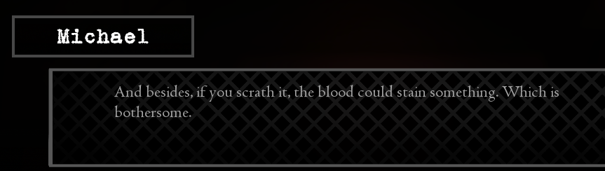

“Scratch” I’m assuming instead of “scrath”

Phrasing is clunky here

No other bugs besides the one exception day 1, on to day 2 week 3

“if” instead of “is,” I know it’s obvious but I’m just bringing it to your attention

“Releasing” instead of “relasing”

Said I was scared of Michael, placed the blame on him, now Elisabeth’s second event is available for some reason. It might’ve been available earlier. I don’t know if that’s a bug or not but I’m reporting it.

No you don’t have four of them

Alright, game’s broken. Saw Elizabeth’s third event and it gave me gameplay on Saturday. Going back to the Sharpe interview about Michael

Sharpe dialogue branch 1 then 2, further down the line, “shaken” might be more professional, but I guess her internal monologue could include this just fine

Day 5, “tilts” instead of “tils”

Personal note, if Caroline called me I would leave the room with Michael in it first. ~~He’d hear her voice.~~

Okay good. He recognized it. I guess that was intentional.

After touching his shoulders day 5, “forgive” sounds better than “forgave” here

Build B ending achieved, time to test some dialogue trees

Saying he forced me to free him to Sharpe seems to give a weird unfinished route that leads to working on Saturday. I hate working on Saturday.

Also worth noting, Sharpe says “a few days of rest” and then Hart returns to work the next morning